

Forensics Report CA1



TU8??

BSc in Computer Science

**Mark Clancy Sutton**

**C20437052**

School of Computer Science

TU Dublin – City Campus

**20/10/2023**

**Table of Contents**

*1.* *Case Introduction* 5

*2.* *Summary of the information* 5

*3.* *Forensic Tools and Techniques Used* 5

*4.* *Forensic Examination* 6

*5.* *Findings* 6

*6.* *Recommendations* 6

Declaration

I hereby declare that the work described in this dissertation is, except where otherwise stated, entirely my own work and has not been submitted as an exercise for a degree at this or any other university.

Signed:

Mark Clancy Sutton

Mark Clancy Sutton

20/10/2023

**Case Information**

**Case Number:** 3241

**Offense:** Suspected information theft – breech of internal policy

**Submitting Officer:** (Name/ID#) Kyle Reese

**Victim:** N/A

**Suspect:** Barry Allen

**Date/Time Seized:** 5th Oct 2023 @ 17:33

**Location of Seizure:** 123 fake Street, Dublin (Level 2, office 2-12)

|  |  |  |
| --- | --- | --- |
| **Description of Evidence** | | |
| **Item #** | **Quantity** | **Description of Item** (Model, Serial #, Condition, Marks, Scratches) |
| **1742-1** | 1 | TDK 16GB USB Flash Drive – TF10 USB 2.0 Flash Drive  Asset Tag:  Good condition, no external marks present.  Hardware Asset tag: 45378 |
|  |  |  |
|  |  |  |
|  |  |  |
|  |  |  |
|  |  |  |
|  |  |  |
|  |  |  |
|  |  |  |

|  |  |  |  |  |
| --- | --- | --- | --- | --- |
| **Chain of Custody** | | | | |
| **Item #** | **Date/Time** | **Released by** (Signature & ID#) | **Received by** (Signature & ID#) | **Comments/Location** |
| **2341-1** | 5/10/2023 18:03 | Kyle Reese  Head of Security | Cameron Phillips  Head of IT | Drive stored in the company safe in a secure storage container onsite. Lock code is in the company password register. |
| **2341-1** | 6/10/2023  09:02 | Cameron Phillips  Head of IT | Miles Dyson  Systems Manager | Drive released for imaging. |
| **2341-1** | 6/10/2023  10:12 | Miles Dyson  Systems Manager | Cameron Phillips  Head of IT | Drive stored in the company safe in a secure storage container onsite. |
|  |  |  |  |  |

Appendix A:

|  |  |  |
| --- | --- | --- |
|  |  |  |
|  |  |  |

**Examiners Details**

Mark Clancy Sutton – Head Examiner – Completed the forensic investigation bar the imaging of the drive

Miles Dyson – Systems Manager – Imaged the drive

# *Case Introduction*

A company (Superfake Inc) have requested our forensic services to examine a thumb drive

found on a company employee during a routine search when leaving the building.

This search is mandatory and is part of the company’s employment contract. The nature of

the company’s research and general safe servicing and repair is confidential and subject to a

number of government contract worldwide. Employees are not permitted to bring

computer hardware or equipment in or out of the building. The scanner detects metal and

computer components and will sound an alarm if an object is detected.

On Thursday 5th Oct 2023 @ 17:33 an employee of the company (Barry Allen) passed

thorough the scanner and the alarm sounded. The security team have a procedure they will

follow in such a scenario. The employee is requested to take two steps forward to create

space from anyone else in the queue and to answer the following questions:

1. Have you any metal items or computer components on your person?

2. Do you wish to remove an item from your person and go through the scanner again?

3. If the answer to question 2 is “no” a search of the person and their property must be

conducted.

The search procedure required the employee to be accompanied to a room for a search to

be conducted. The search procedure has been approved by the company’s legal team and is

in full compliance with its statutory any legal responsibilities.

The employee answered no to question 2 and was accompanied to the search room. A USB

key was found in Barry’s coat pocket. Barry Allen stated he did not own the drive and he has

no idea how this got into her pocket. This interaction was recorded and is documented in

the company’s CCTV footage.

Once the search was completed the security team secured the USB Key and placed it in a

secure storage container to be placed in a secure chain of custody. Barry Allen was present

for the storage of the device and this is part of the CCTV footage. The container has a secure

4 digit pin combination which was set by the security manager and documented in the

company password register which resides in the company safe. The container was placed in

the safe by the security manager and was supervised by the CTO and a member of the HR

team.

Images from the acquisition of the USB Key:

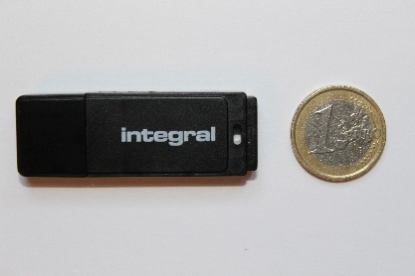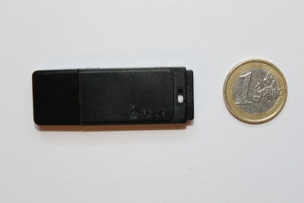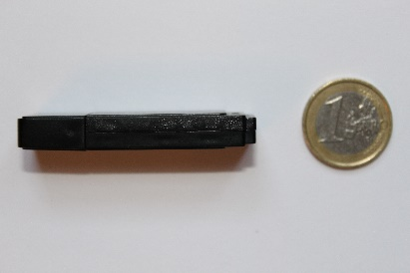

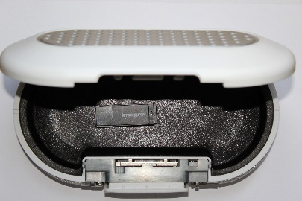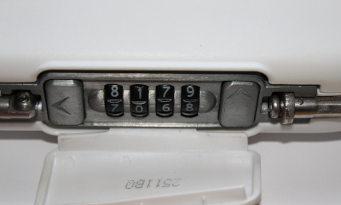

Following the company’s policy and procedure the chain of custody document was created

by the manager of the security team. (See Appendix A for larger images)

A forensic image of the USB key was created by the Systems Manager (Miles Dyson). It is

noted that a forensics team may prefer to create their own image. The Systems Manager

has completed the required certification to complete this task and the company have a lab

with all the appropriate hardware

# *Summary of the information*

The information source for this forensic investigation is a TDK 16GB USB Flash Drive – TF10 USB 2.0 Flash Drive shown above as appendix A. The forensic investigation was done on a forensically sound image of this drive done by Miles Tyson. We are required to parse through the image of the drive and present any information that we discover on the drive. The forensic investigation is to determine if any sensitive documents have been stored on the drive.

# *Forensic Tools and Techniques Used*

Forensic Workstation details.

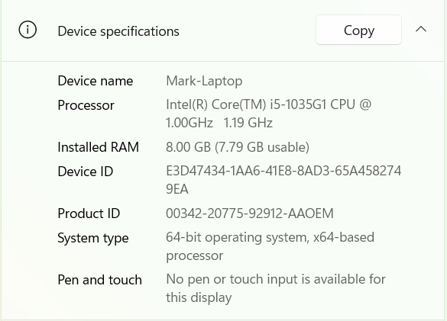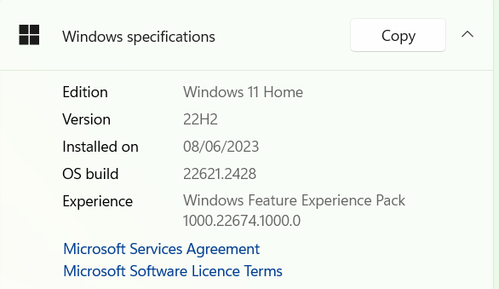

Tools Used in the Investigation:

. Autopsy 4.21.0

. HxD Hex Editor 2.5

. FTK Imager 4.2.1

. Microsoft Photo

. Word

. Excel

. Notepad

. Tableau UltraBlock External Write Blocker

. Faraday shield

Miles took the forensically sound image of the drive which was used for this forensic investigation. He first connected the pc adapter cable to the forensic workstation and then to the hardware write blocker. Next, he connected the suspected flash drive into the hardware write blocker. Next, he connected the power supply to the hardware write blocker then turned it on. He made to connect these cables to the fastest available port for this case the usb 3.0 slots to make this imaging process move as fast as possible. He then checked to make sure the power on light on the write blocker was green indicating it was indeed on. Then the light for host and device also turned green indicating they have been successfully connected to the device. Next Miles opened FTK Imager on the forensic machine and went to file then create disk image where he selected physical drive.

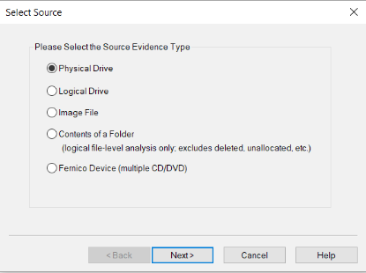

Then he selected the correct drive from the drop down menu and hit finish.

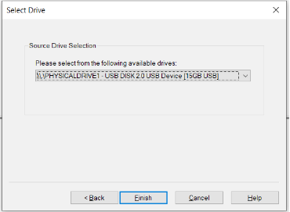

Then clicked add and selected raw dd as that format is accepted by most forensic tools

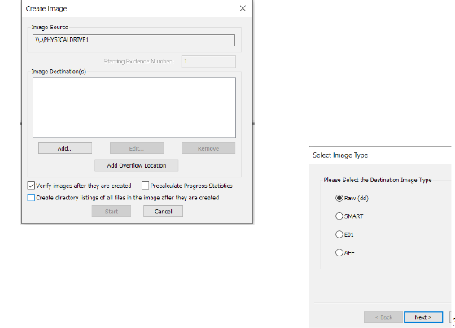

Next he filled in the case information

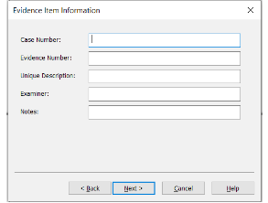

Then he selected the location for the new image to be stored

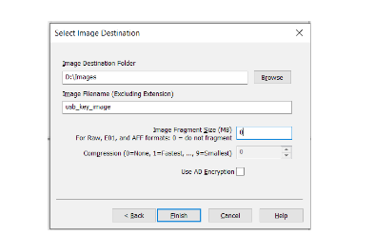

# *Forensic Examination*

Detailed description of the process followed as part of your forensic examination.

This should be in chronological order.

(Maybe each task should get its own sub-section)

The process followed should be documented in detail (eg. Everything we did to recover the data)

I received the forensically sound image form Miles then immediately opened it up in an autopsy case and began looking through the drive. Initially began by taking a look at how the drive was partitioned and the specifics of the file system and where such things might be located. Below is an screenshot of the initial opening of the image using autopsy including a look at the file system of the drive

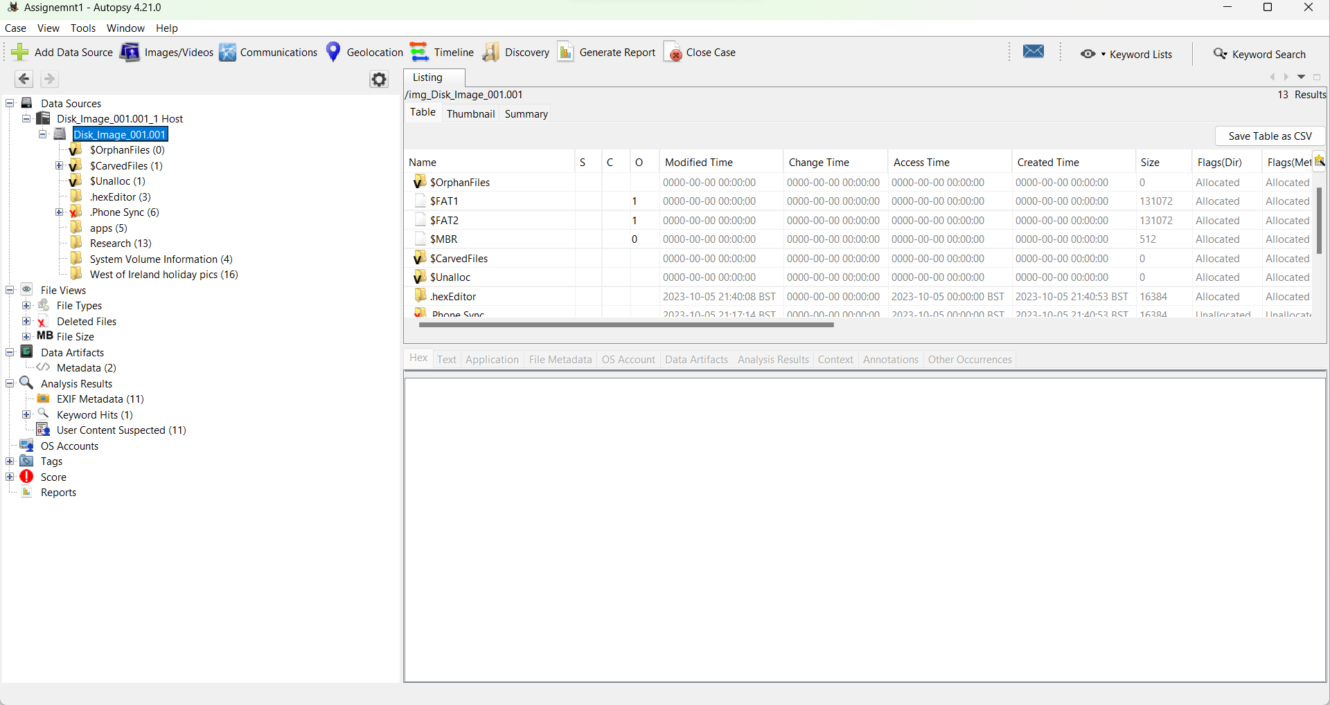

Next thing I did was scan through the files that I could access the mainly for this drive that was all the photos available in the drive. I looked through the photos too see if any of them would be important to the investigation. The main brunt of the photos were recoverable by autopsy but some were not. Some of the photos were edited by a hex editor from what I could tell as there was a hidden image in this below file.

img_Disk_Image_001.001/Research/20231005_124735.jpg

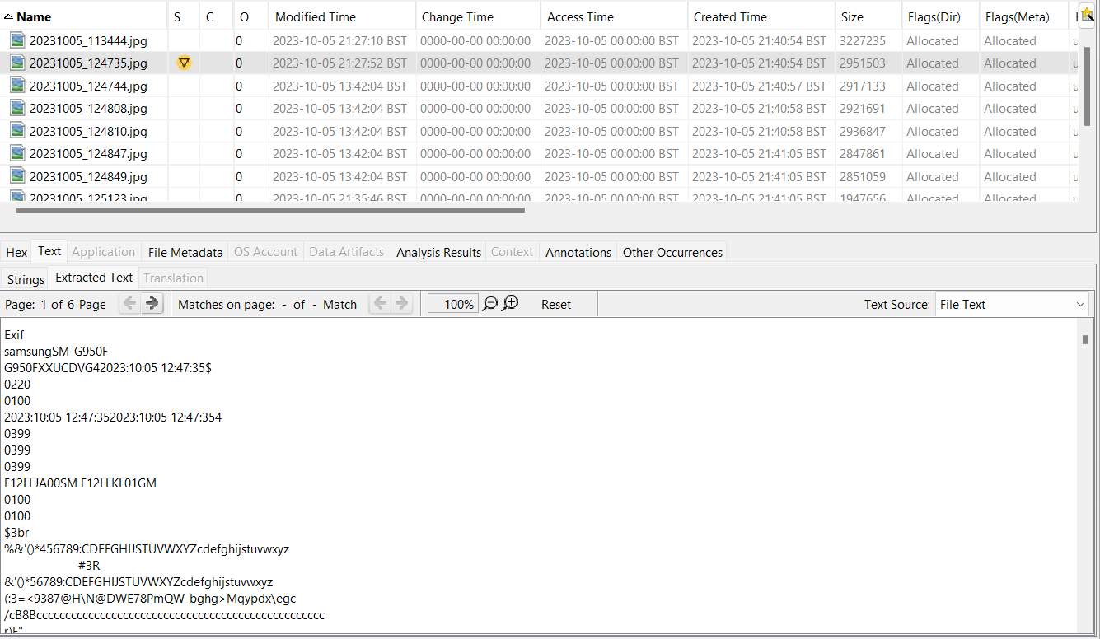

Even autopsy flagged this image as being suspicious which later I will show the image that was recovered that was hidden within this image. There was another hidden image in a file that was the same image as one that was already on the drive. The file that contains this hidden image is 20231005_113444.jpg and it’s the same as f0000320.jpg. The rest of the forensic investigation was just looking through the metadata of the files and checking to see if anything else was hidden or could be accessed while cataloguing a timeline of events that occurred based on this data. One thing that was discovered was that there was an encrypted excel sheet with that could be opened with a password seen in one of the passwords it was Qwerty2023.

# *Findings*

Here is the beginning of the timeline with the chatlog timestamps which are on the 5th October at 11:25 which seems to be edited as this was created at 2023-10-05 21:40:53 BST

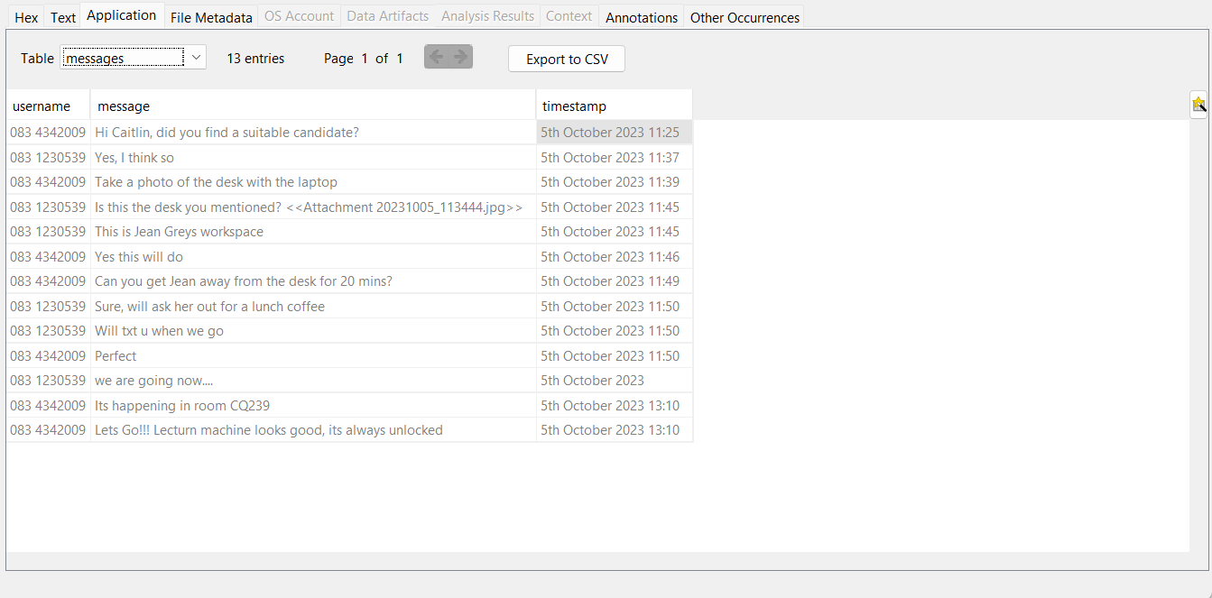

Named: img_Disk_Image_001.001/.Phone Sync/attachments/20231005_113444.jpg

Created at: 2023-10-05 21:40:53 BST

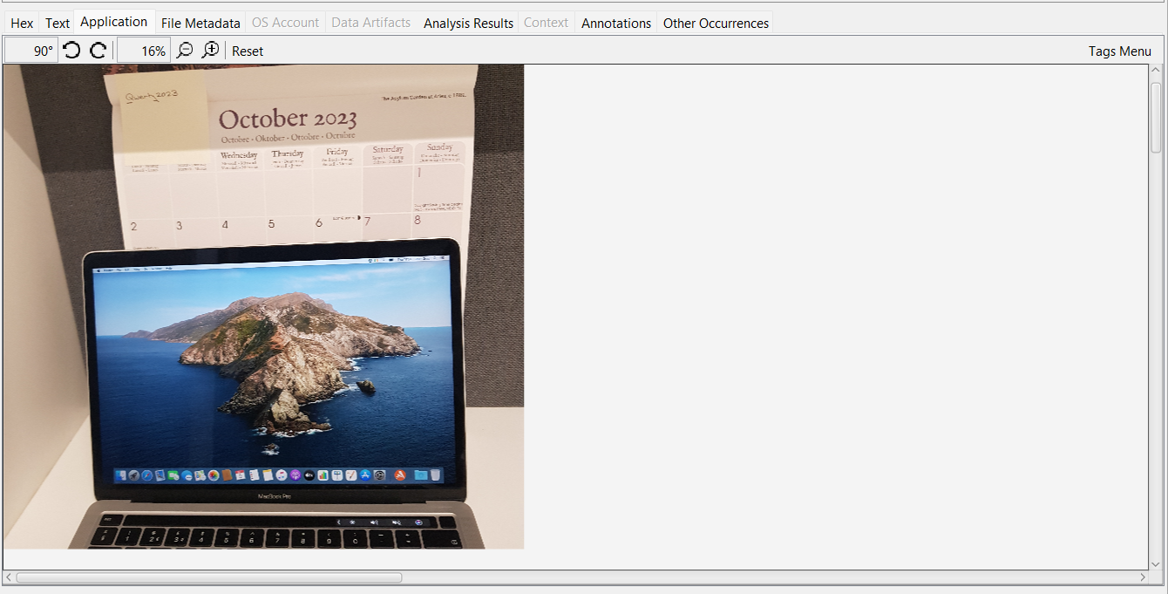

The file above contained a hidden image which is the same as the one above :

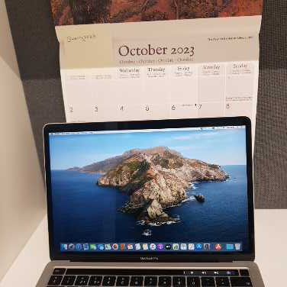

Here is the metadata for the file that was edited where a hidden image can be found

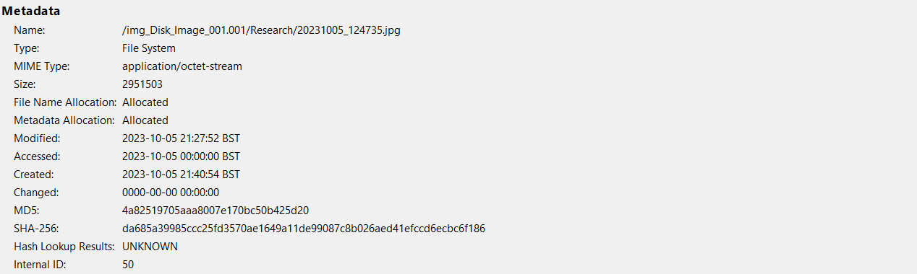

The hidden image is this:

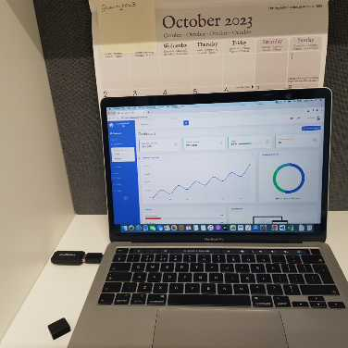

The Next image taken was

/img_Disk_Image_001.001/Research/20231005_124744.jpg

And created at : 2023-10-05 21:40:57 BST

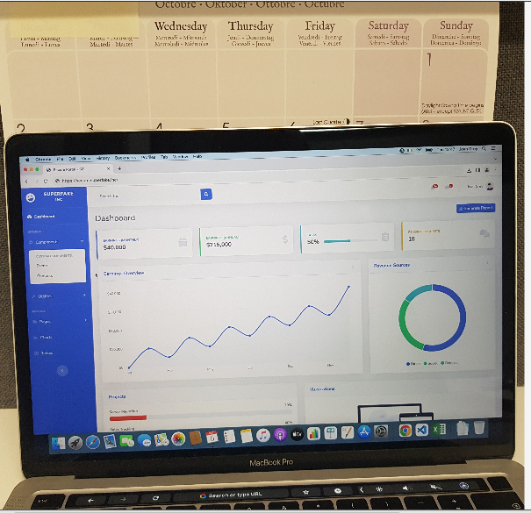

The next image was /img_Disk_Image_001.001/Research/20231005_124808.jpg

Created at 2023-10-05 21:40:58 BST

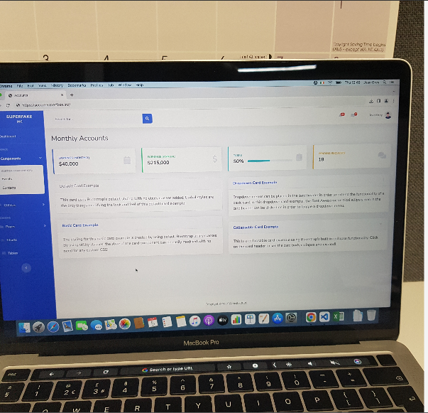

The next image is /img_Disk_Image_001.001/Research/20231005_124810.jpg

Created at: 2023-10-05 21:40:58 BST

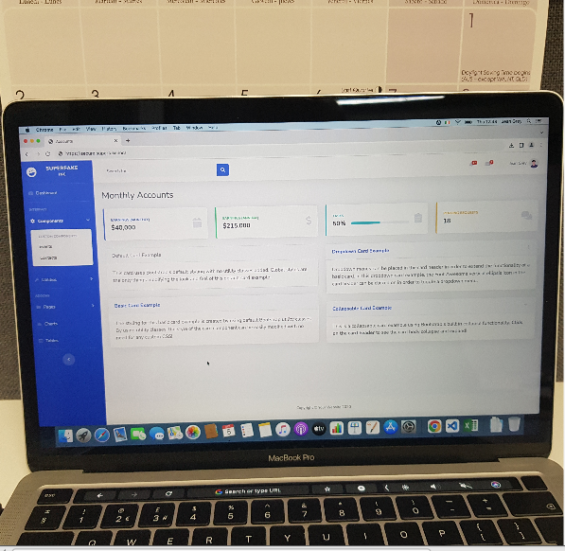

The next image is /img_Disk_Image_001.001/Research/20231005_124847.jpg

Created at 2023-10-05 21:41:05 BST

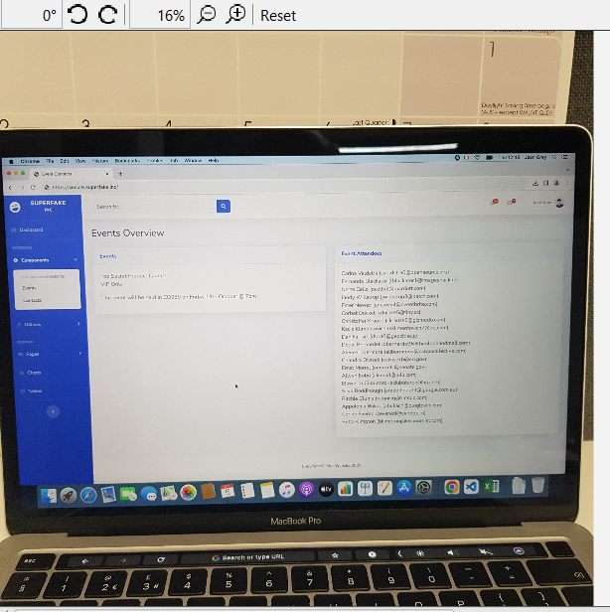

Next is this image /img_Disk_Image_001.001/Research/20231005_124849.jpg

Created at: 2023-10-05 21:41:05 BST

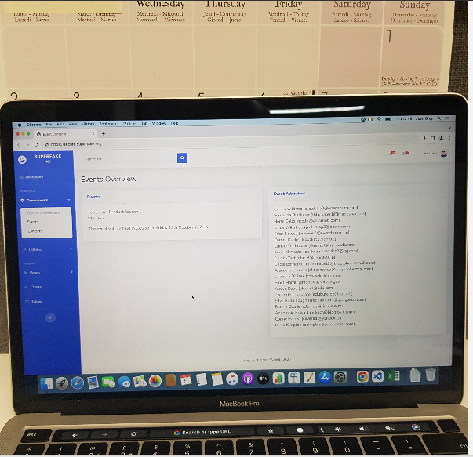

The next image is an image that has been changed this is it without being successfully carved back to the original it is called /img_Disk_Image_001.001/Research/20231005_125123.jpg

Created at: 2023-10-05 21:41:05 BST

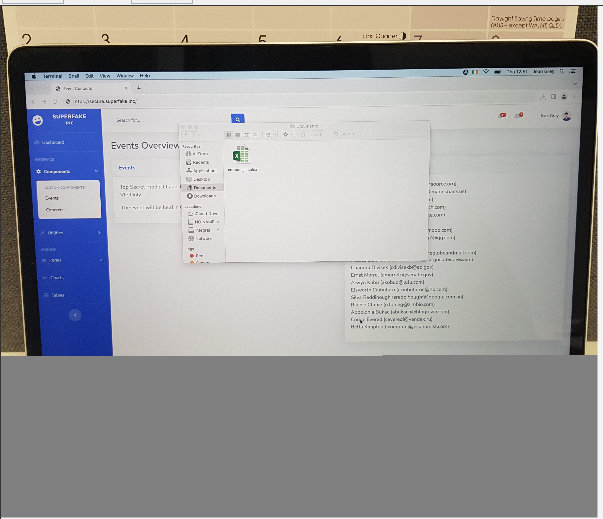

Then the recovered image is this:

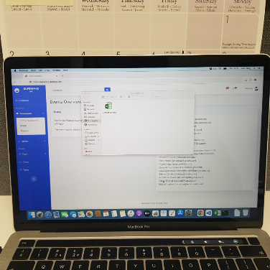

Next is this image named: /img_Disk_Image_001.001/Research/20231005_125954.jpg

Created at: 2023-10-05 21:41:08 BST

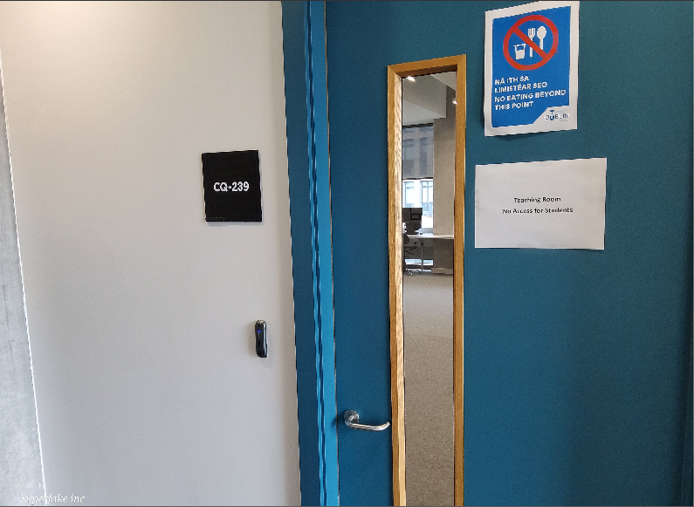

The next image is /img_Disk_Image_001.001/Research/20231005_125957.jpg

Created at: 2023-10-05 21:41:09 BST

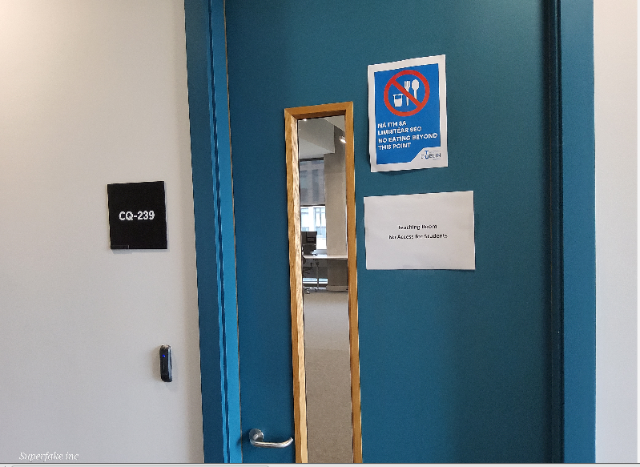

Next image is /img_Disk_Image_001.001/Research/20231005_130002.jpg

Created at: 2023-10-05 21:41:09 BST

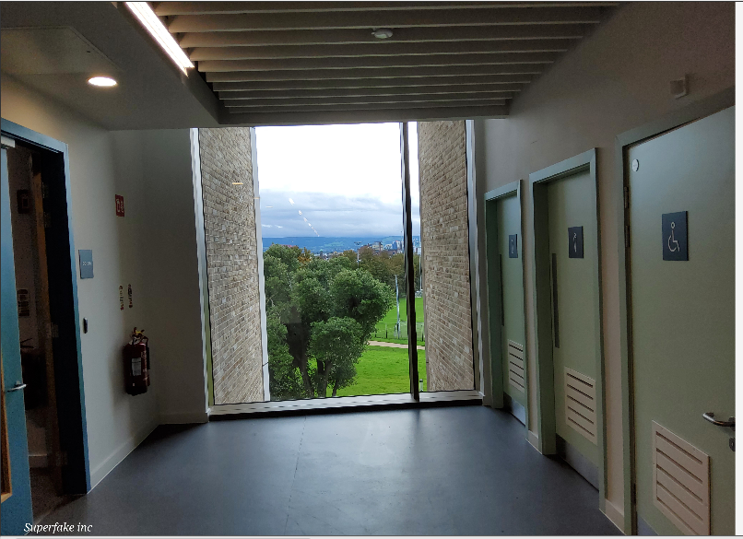

Next image is /img_Disk_Image_001.001/West of Ireland holiday pics/Photo_1.jpg

Created at: 2023-10-05 21:41:16 BST

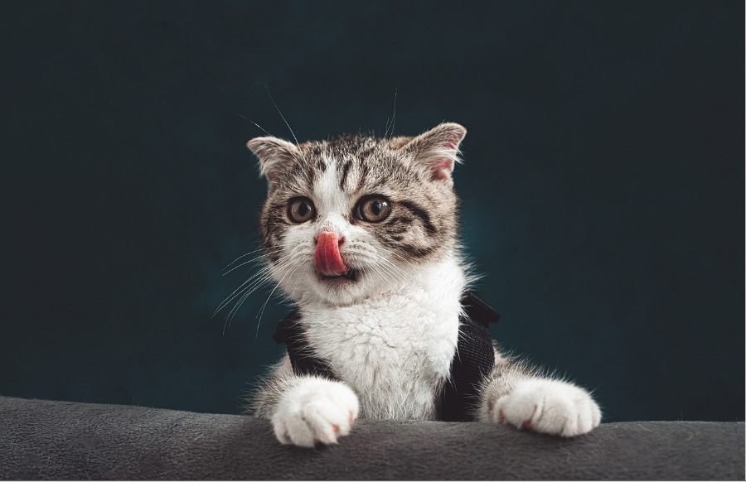

The next image is /img_Disk_Image_001.001/West of Ireland holiday pics/Photo_2.jpg

Created at: 2023-10-05 21:41:16 BST



The next image is /img_Disk_Image_001.001/West of Ireland holiday pics/Photo_3.jpg

Created at: 2023-10-05 21:41:16 BST



The next image is /img_Disk_Image_001.001/West of Ireland holiday pics/Photo_4.jpg

Created at: 2023-10-05 21:41:16 BST

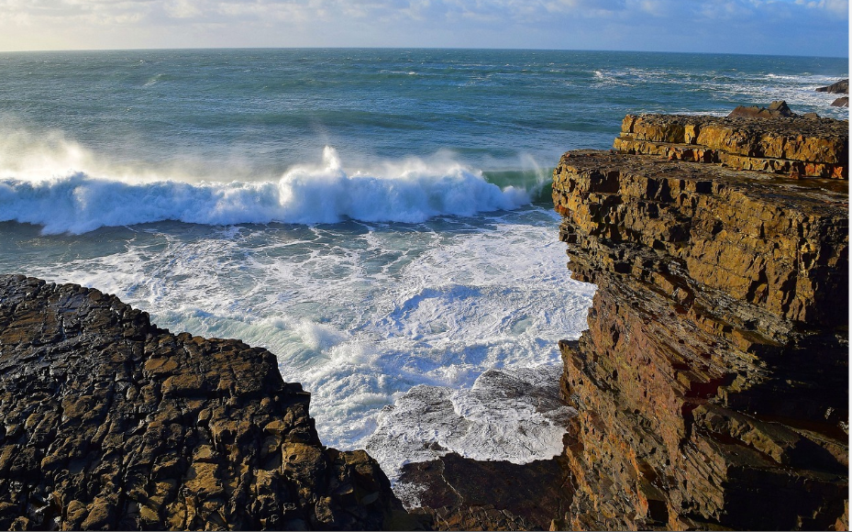

The next image is /img_Disk_Image_001.001/West of Ireland holiday pics/Photo_5.jpg

Created at: 2023-10-05 21:41:16 BST



The next image is /img_Disk_Image_001.001/West of Ireland holiday pics/Photo_6.jpg

Created at: 2023-10-05 21:41:16 BST



The next image is /img_Disk_Image_001.001/West of Ireland holiday pics/Photo_7.jpg

Created at: 2023-10-05 21:41:16 BST



On the 5th of October at 12:12:30 this document was created called

/img_Disk_Image_001.001/$CarvedFiles/1/f0006784_Microsoft_Word_Keylogger_Tutorial.pdf

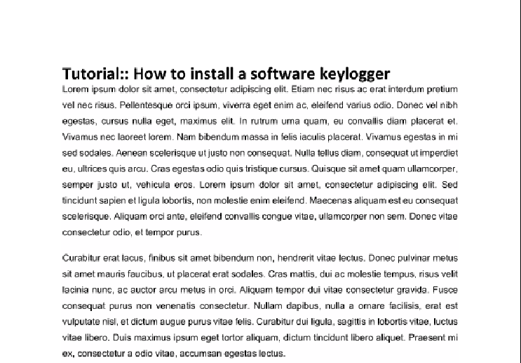

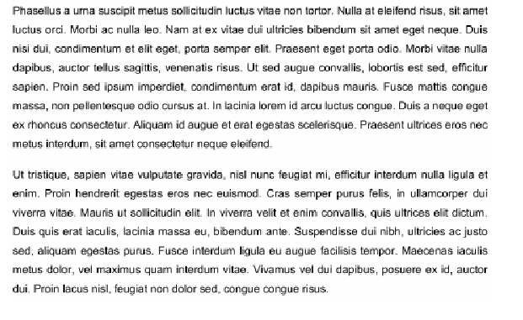

# *Recommendations*

The investigation in my opinion should continue as there is enough evidence that should not have been on a hard drive exiting this company. This should be looked into further and maybe be investigated by the authorities or handled by the employers at their own discretion. The only other thing that could be done is there are a few encrypted files that couldn’t be accessed so handing those to an expert for further investigation would be wise. Also, a lot of files that couldn’t be recovered could have an expert look into those then more information could be found and be useful for the investigation as a whole to get the full picture.